Chapter-3
EMBED AFFECT AWARENESS in E-LEARNING: A SYSTEMATIC OUTLINE of the LITERATURE
Snehal R. Rathi¹*, Yogesh D. Deshpande²

1 Department of Computer Engineering, Vishwakarma University, Pune, * snehal.rathi-023@vupune.ac.in
2 Department of Computer Engineering, Vishwakarma University, Pune, yogesh.deshpande@vupune.ac.in
Abstract. In recent years, web based education has been perceived as a support tool for instructors as it gives comfort of using it at anytime, anyplace. Engineering educationalist relies on scientific labeling, like Bloom's classification to make learning goals used to build up lesson’s contents. As per Bloom's scientific classification lessons goals can be arranged into three spaces: cognitive, affective and psychomotor area. While evaluating the learners in E-learning, most encouraging courses just put down weight on facts broadcast, to be specific, the cognitive area, and ignore learners learning mentalities and feelings due to the distance.
An emotion plays a very noteworthy part in the cognitive procedure of individual, so the change is deficient with no capturing the student's passionate state. With the help of the affective computing technology, it is possible for researchers to understand learner’s affect during online learning and then they are able to take corrective action.
This chapter presents an organized review related to affective computing technology. The chapter explores and spots the different modalities, techniques, tools developed and emotions identified by researchers to realize their practicability and development. Finally, few challenges are listed for helping researchers while applying affective computing technology. Total 61 research papers are incorporated in this survey. The result reflects that data is a major concern in this area and very few data sets with some modalities are only available. Most of the researchers have used facial expression modality for prediction of affective states. Many authors has used generalized term affect while prediction. There is yet a lot of scope in prediction of academic emotions like confusion, engagement, frustration etc. The overall evolution of the research goes through various changes in terms of modalities, technologies, tools and data are targeted.
Keywords. Bloom's scientific classification, E-learning, Affective area, Affective States, Learner’s emotions.
  - Introduction
Education via the web has opened many doors in the present education scheme. E-learning is fundamentally the framework enabled trade of talent and information by the online instructors to the online students. Web based learning beats the constraint of reality by presenting extravagance of its client to make utilization of it at whenever, anyplace. Similar to usual learning, web based adapting likewise relies upon influential communication of human information, in spite of whether this happens in an eye to eye study hall or over the Internet. An educator depends on scientific classification, like Bloom’s scientific classification to make learning goals used to build up teaching contents and exercises. Many times, faculty uses these goals to assess student achievement. It has attractive impact on objectives-based appraisal [6].
Bloom’s taxonomy in E-learning helps the instructors to think and analyze their teaching and student’s learning. It is used to state clear objectives which can help the teachers to plan lessons accordingly [5]. Bloom’s Taxonomy guides the teachers to change the complexity of the questions and helps scholars to acquire greater ranges of hierarchy. Further, it helps to develop critical thinking among teachers. According to Bloom's scientific categorization, lessons goals can be prepared into three spaces: intellectual area, knowledge; Affective area, mentality; and psychomotor area, skills [7]. After the educational strategies are completed, college students must be assessed whether or not they have achieved the presented goals. In the group of students, when the guidance strategy is preparing, the educator always applies several varieties of educating competencies or create inquiries to inspire learners to be thoughtful for accomplishment of affective area instructing goals. The greater part of these aptitudes and approaches are the method of collaboration [3]. E-learning has grown quickly in last few years, and turned into a pattern of learning [4]. For students’ assessment, this framework needs to be planned with the evaluation feature [8]. The widely used evaluation method in distance teaching and learning is on-line examination [8, 9]. Nonetheless, most instructing courses just put down weight on information broadcast, in particular, the knowledge area, and forget about learners learning mentalities and the affective area educating goals. Because of the distance, instructors cannot survey the accomplishment of affective area educating goals. But, if instructors can understand the student's affective condition via the mastering framework, they can defeat the trouble.
As shown in Fig. 1, Emotions have giant influences on learning and has a very noteworthy role in conclusion making and reflecting on the studies. Negative Affect comprises an assortment of bad feelings consisting of outrage, disturb; blame, fear and nervousness can deeply impact training and learning. Bad feelings influence learner’s inspiration and learning. It gets hard for student to manage learning exercises and timings. Answer for this is affective computing technology. Consequently, understanding a student’s have an effect on all via the learning methodology is critical for getting motivation. In ordinary training research, student motivation can be recognized via questionnaires after occasion. With the development of affective computing, creators can fairly perceive and assess a learner’s affective state at the time of learning in a continuous way [14] and thereafter they can appreciate the interrelationship between feeling, inspiration and learning execution.
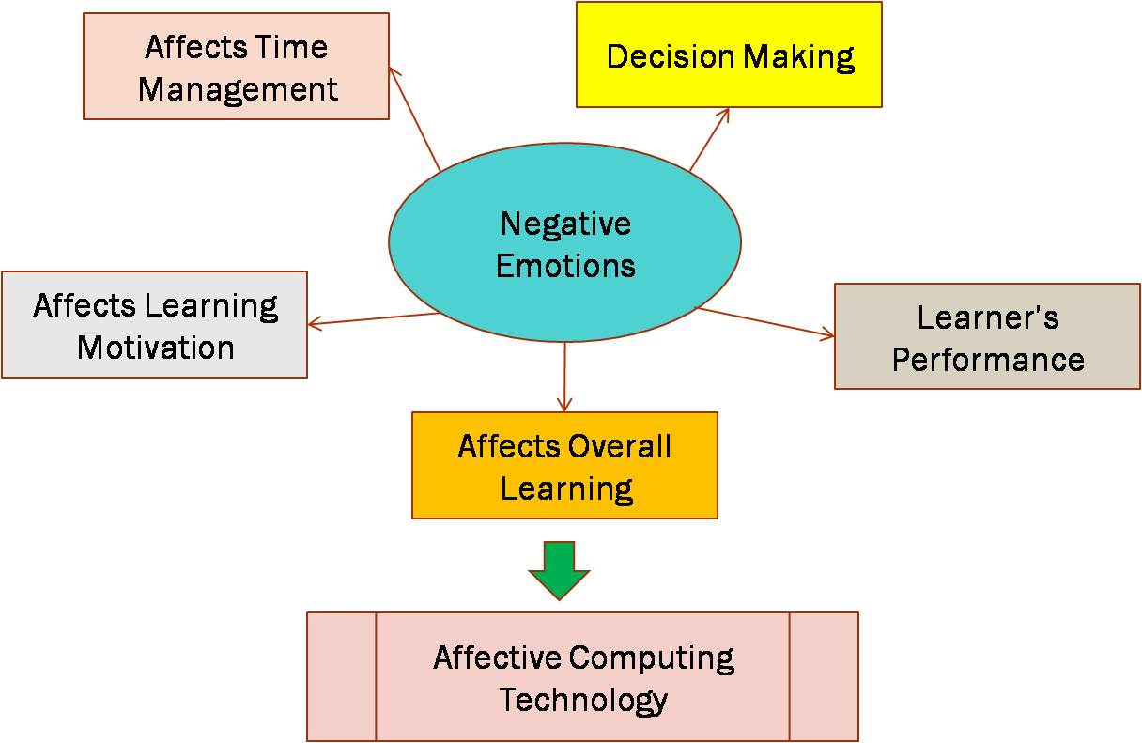

Fig. 1 Role of Emotions in Learning
Therefore, E-courses must place the same importance on the needs of the affective domain along with the cognitive area.
E-learning has been portrayed as less emotion sensitive and greater impersonal due to not acknowledgment of non-verbal communication and gestures of the learner while comparing it to traditional education [9]. On the off chance that internet learning frameworks don't give constant input to the student, at that point student doesn't get the advantage of getting the real comments of mastering performances at some stage in the learning procedure. The student's feelings greatly affect the student's inspiration towards better learning.
With this understanding of importance of affect in E-learning, we are presenting here an organized review of 61 selected papers in this area from 2009 to 2021. These papers are included in the survey after intense scrutiny. Here, we focus on different modalities/instruments, techniques, tools developed and emotions identified by the researchers.
Section 1.2 includes Motivation for this research. Section 1.3 of this chapter represents strategy used in this survey and research questions based on which the survey is designed. Section 1.4 gives the details of related literature included in the survey. Section 1.5 gives survey outcomes and discussion and taken as a whole survey is concluded in Section 1.6.

  - Motivation
As shown in Fig. 2, with traditional teaching methods and high understudy/educator proportions, an instructor faces great obstructions in the study hall. Customarily, educators convey the substance and understudies gain knowledge of it. Using this technique, instructors are normally not ready to react to the individual needs of understudies. Besides, because of the huge quantities of understudies in a class, educators cannot concentrate towards every individual understudy. For reviewing they consistently direct a test towards finish of the course. Nonetheless, in spite of the high number of understudies in a study hall, experienced educators typically watch, perceive and tackle the learning way and affective state of the students [31]. The gifted instructors make proper move to emphatically affect knowledge. Be that as it may, the question is the thing that these accomplished instructors “sees" and how they appear at a procedure and whether this movement drives the understudy to a gainful way. Student's learning not only relies on factors like the instructor's teaching style, a student's capacity and a prerequisite but also depend on the compatibility of emotions.
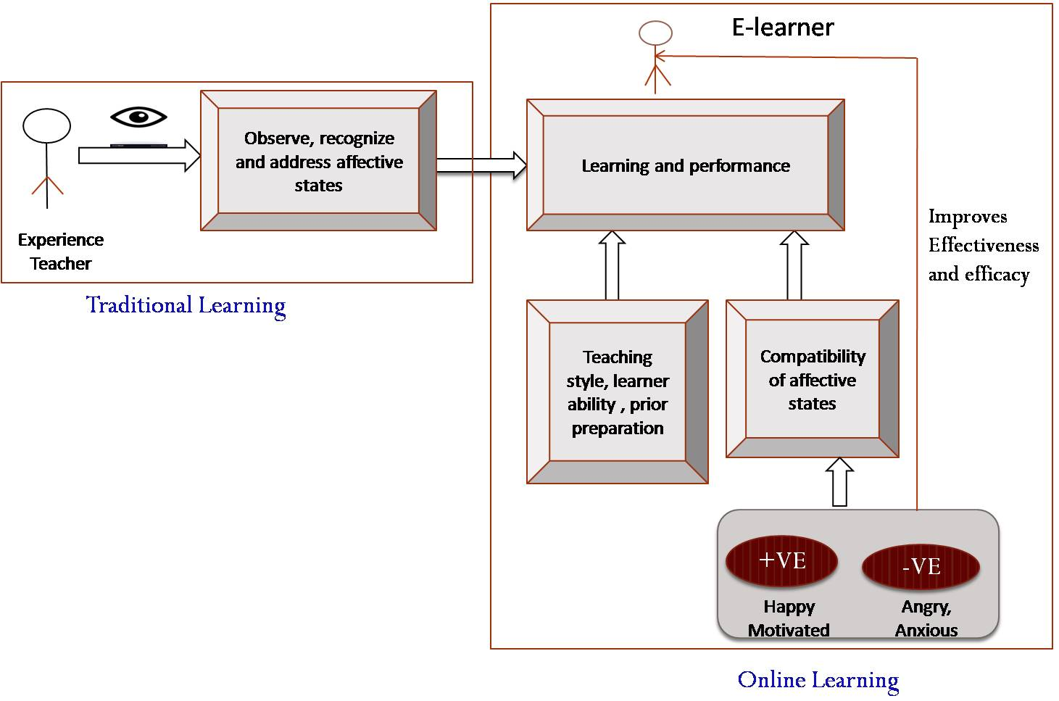Fig. 2 Research Motivation

The degree to which enthusiastic miracles can meddle with mental existence is no news to educators, understudies who are irate, on edge, or discouraged, experience issues in learning. Individuals trapped in these states don't receive data effectively or manage it very well [1]. Nonetheless, the connection among learning and feelings is a long way from being that straightforward and direct. Good and bad affective states produce distinctive sort of reasoning and this may hold noteworthy inference from learning viewpoint. A reliable theory of discovering that incorporates effectively cognitive and affective factors are robustly required [2].
Gifted educators alter the learning way and their encouraging style as per understudies input signals (which incorporate intellectual, enthusiastic and inspirational perspectives), online learning frameworks mostly don´t consider these criticism signals resulting too strict and undermined, as they act in similar way for all understudies. Most of the online learning structures focus on data acquiring or intellectual handling.
While building a framework, affective states are viewed with respect to how the content is organized and introduced. To make learning effective there is a need to build up a learner’s model that coordinates the intellectual cycles and inspirational states [9]. Changing an e-learning framework from non-affect sensitive to a framework that incorporates user’s affect requires the representation of a circle called as the affective circle. The affective circle envelops recognition of passionate states, proper activities choice for conclusion making, and the fusion of suitable affect by the framework [8]. Students, who get trapped in bad states like depression don’t process and hold information proficiently. Through this, it tends to be construed that a user’s affect has a noteworthy role in enhancing the viability of e-learning [10]. With this understanding of affect in E-learning this survey is initiated.

  - Research Strategy and Research Questions
The survey related to ‘Affective Computing’ was carried out in an organized way by following the steps mentioned in Fig. 3. Initially, research questions are designed to provide a suitable path to the review. We take it forward with retrieval of allied research papers and then done scrutiny and selected the most relevant research papers. Finally, the findings of the respective authors are studied and cited along with parameter they have measured in their research.

Research Questions
Retrieval of related research papers

Scrutiny of most relevant research papers
Extraction of required parameters
Verify and record result

Final set of papers taken in survey

Fig.3 Steps of Strategy used for Literature Survey

To aim the organized review, the following research questions are identified:
Q1. Which modalities/instruments are used in affective computing study?
Q2. Which emotions and parameters are measured by the researchers?
Q3.Which datasets are used by the researchers for prediction of affect?
Q4. What are challenges facing this research area?
  - Literature Review
Emotions and online-learning are connected with one another. The learning execution mirrors, the affective status of online learners in the existing setting of the web based learning in advanced education. There has been a lot of enthusiasm among computer researchers and designers searching for approaches to progress person and workstation interaction by synchronizing emotion and cognition with task imperative [23]. Affective Computing makes the chance of creating computational frameworks for acknowledgment of human affective states and minimize the gap among the profoundly expressive individual and the emotionally challenged computer [23]. Subsequently, Affective Computing research is an interdisciplinary area that plans to investigate human emotional involvement with technology by combining engineering and computer knowledge with areas like brain science, intellectual science, humanism, education and morals [16].
These technologies sense the emotions of an individual by using a mix of various information sources – facial expressions, voice recognition, gestures, sensors [13], eye movement, behavioural log analysis and questionnaires.
Affective computing is a developing field uniting scientists and specialists from different fields, extending from AI, NLP to cognitive and sociologies [20].
The latest couple of years have seen a flood in the utilization of multidisciplinary procedures to consider the difficult role of emotions in a large number of learning settings. Sentiment analyses has picked up fascination in the Computer Based Education research network, maybe due to the interdisciplinary idea of many research teams that include proficiency in brain science computations and NLP.
Emotion information is utilized to improve learning [30]. Here, positive and negative emotions were recognized by utilizing two unique models like behavioural patterns log record and biosensors. Fusion of it is done using Bayesian network [24].
Sandanayake and team have built up a system to know the students online learning performance while estimating the emotional state. Here creators have determined affect from survey and learning performance from standards of conduct in the log record. Few positive and negative emotions were estimated. Critical connection found between the emotions and log record information estimated [17].
Kort has built up an affective model of interaction among emotions and learning.
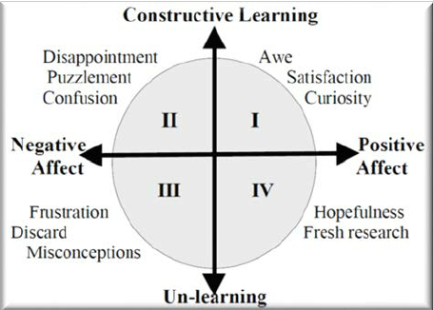
Fig. 4 Kort’s Learning Spiral Model
The flat line is the emotion axis and at right angles is the learning axis. As indicated by Kort in Fig. 4, understudies preferably start with quadrant 1 and may enter into further quadrants while learning where their emotion is bad and have Un-learning state. If understudies get proper support at this point they may move towards hopefulness state [18].
Every student has diverse learning style yet sadly, present E-learning frameworks assess all the students in an equivalent manner. Students learning is rely upon their learning style and affective states. Here authors have recognized students feeling and learning styles (Active or Reflex, Sensitive or Intuitive etc.) from log document. Authors have referred the Fielder Silverman Learning Style Model (FSLSM). As indicated by Fielder Silverman, distinguishing learning styles [11][12][19] are portrayed in Table1.

Table1. Fielder Silverman Learning Styles
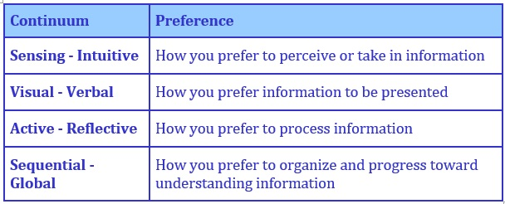
Multimodal combination gives preferable outcomes over the unimodal investigation. There are various sorts of combination strategies utilized for multimodal fusion that are early fusion, late fusion and hybrid fusion. Finding summed up model and utilization of deep learning for multimodal fusion is significant future work in this area [20].
Affective PC not only gives improved execution in helping individuals, but also improves PC’s capacities to decide. In view of this proof, to construct PCs that make intelligent decisions may require construction of computers that have emotions [16].
In online learning environment, feelings majorly affect basic psychological cycles; neurological evidence shows they are not a luxury. Here authors have featured a few outcomes from the neurological literature which demonstrate that emotions play a fundamental job in human imagination and knowledge, however furthermore in critical human thinking and conclusion-making. PCs that will collaborate as expected and intelligently with people require recognizing and expressing affect [15].
Some experiment took data from biosensor wearable gadgets like smart watches and fit band. Authors have utilized here emotionWear Framework. In emotionWear framework a user watches the contents in the Smartphone which incorporates VR headset and it is associated with the cloud storage. The user wears remote detecting gloves which produce various signs which are utilized to recognize emotions of the user. The emotions detected were exact yet there was delay in investigation [27].
Most of the work aims to discover affect using facial expressions and sensors. The overall purpose is to enhance accuracy and take some corrective action to enhance learning. Researchers have performed experiment on data collected at various universities and labs. Different tools were developed by the researchers for data collection and analysis. Table 2 summarizes the parameters measured, modalities used, methodology and final outcome of the papers included in the survey.

Table 2: summary of the parameters measured, modalities used, methodology and final outcome of the papers

Sr. No. | References | Parameters Measured | Modality/  Instrument | Methodology | Benefit/Outcome
1 | Liping Shen [32] 2009 | Interest,  Boredom,  Confusion,  Satisfaction Frustration,  Engagement Hopefulness, and Disappointment | User Profiles and Learning Events and Biosensors are used. | Study was guided by Russel's Circumplex Model and Korth model. Authors explored evolution of emotions at the time of learning and observed use of emotion feedback to improve learning. | Experiment confirms performance of emotion aware module over non-emotion-aware is more.
2 | Farman Ali Khan [33] 2009 | i. Emotions: Confidence, Confusion, Independence and Effort  ii. Learning Styles | Behavioural Log File: Consist of 16 factors | Both Emotion and Learning Styles are identified from Log file. | Tool is presented for detection and calculation of various styles of learning and  affect.
3 | Farman Ali Khan [34] 2010 | i. Emotions: Confidence, Confusion, Independence and Effort  ii. Learning Styles | Behavioural Log File: Consist of 16 | i. Both Emotion and Learning Styles are identified from Log file.  ii. Adaptive course generator is used.  iii. Adaptive Affective tactic generator module is developed which will do tagging and provide help according to LS and AS. | The investigation of learner’s styles of learning and affect is done for providing them personalized support.
4 | T.C.Sandanayake [17] 2013 | Few positive emotions: Pride, Hope, Enjoyment & Relief and some negative emotions: Anger, Boredom Anxiety, Hopelessness and Shame | i. Behavioural Log File: Evaluating Learners Performance  ii. Questionnaires: Measured Learners Emotions. | Tool is developed to recognize E-learner’s emotions. Multiple regression is used. | i. Identified learner’s learning level and the emotional state.  ii. Correlation between learners observed behaviour and emotions is analysed.
5 | NELL BUISSINK-SMITH [3] 2014 | Affective attributes | Review of primary and secondary source data collection methods are given. | Overview of affective learning in education is given | Framework for measurement of affective attributes is proposed.
6 | M. Feidakis[35] 2014 | Anger, boredom, confusion, fatigue, relief/relaxation, curiosity, despair, excitement, disinterest, embarrassment, inspiration, interest, stress and nothing | Tool Emotcontrol is developed. Self reporting is used. | i. Authors has developed conceptual and computational model.  ii. Implemented model employs self-reporting of affect, feedback and efficient emotion visualisations. | Users found Emotcontrol tool useful, expressive, usable and effective.
7 | Chih-Hung Wu [14] 2015 | Emotions | Details of physiological signals, multimodal based approach and other modalities are given | For realization of latest trends, here authors have summarized measurements of affective computing in learning field. | i. The trends of Affective Computing in learning are discussed.  ii. Multimodal framework for affect recognition is proposed.  iii. Challenges and problems in this field are proposed.
8 | Rachel Carlos [36] 2015 | Affective states in collaborative environment | Review Paper | Literature survey is done to find  i. Frequently used emotional states in collaborative surroundings  ii. Were affective states empirically evaluated?  iii Types of surroundings which makes use of affective states to support group learning | Authors verified that: 54,84% studies deal with ‘emotions’ 51,61% studies were empirically evaluated and LMS and E-Learning systems are the surroundings which makes use of affective states to support group learning.
9 | Manuel Rodrigues [37] 2015 | Affective states and Learning styles | Only framework is given where authors may use  Explicit assumption: Self reporting and Implicit assumption: Facial Agent, Keyboard agent, Mouse agent, Log agent. | Authors proposed framework in which after linking module with Moodle platform, student’s affective states and learning styles get detected and contents were presented accordingly. | i. In this paper, some problems of Moodle are identified.  ii. The framework is proposed here which includes an affective module in Moodle.
10 | Jason Matthew Harley [38] 2015 | Review of emotions in computer based learning | Pro's and Con's of i. self reporting ii. Log files iii. Facial expressions iv. Language and Vocalisation v. Psychological signals are given. | Survey of all methods and modalities is given. The effectiveness of multimodal approaches is discussed. | Multiple methods used to predict emotions with their pros and cons are given.
11 | Arvid Frydenlund [39] 2015 | Affect, dominance,  favourability, valence, familiarity. | Multimodal affect detection is done. Sensors and videos are used. | Here, authors have presented a multimodal system for affect prediction. They have used DEAP data set to train model. They also have introduced a way for extracting video features and creating more training examples from data. | Proposed model performs better for affect, dominance, favourability and valence than baseline methods.
12 | Jyotish Kumar [40] 2015 | Disgust, Anger, Love, Courage | Galvanic skin response (GSR) physiological signal is used to measure electro-dermal responses. | Here, GSR of participants was recorded by placing skin electrodes at the palmer surface while watching videos. By analyzing this data, emotions are detected. | Authors have confirmed the performance by comparing it with verbal reported feedback.
13 | Ashwin T S [41] 2015 | Basic emotions | Facial expressions detecting multiuser faces in E-learning | Here authors have implemented multiuser face detection based e-Learning system using SVM. The method gives 89% to 100% accuracy using different datasets  LFW, FDDB, and YFD. | The method proposed by authors recognizes emotions for several faces in a solo frame.
14 | Nigel Bosch[42] 2015 | Boredom, confusion, delight, engagement and frustration | Facial expressions | Here, authors proposed a method to detect students’ affect. Data were collected in the computer lab. Affect is detected using facial expressions and body movements. | Here, authors has validated face-based detector for  learning- centred affect. They have proved, it was possible to detect affect in the wild even though challenges exist.
15 | Ishan Behoora [43] 2015 | Engagement/ Interest, Delight, Frustration, Boredom | Non wearable sensors like the Microsoft Kinect which captures physical image and motion | Authors have developed a system. Steps of it are as follows.  i. Data acquisition  and feature generation  ii. Detecting body language from these features and mapping emotional state of design team members.  iii. Machine learning modal is trained. | Emotional states are detected with accuracies above 98%.
16 | Abhay Gupta [21] 2016 | Engagement, frustration, confusion and  boredom | Video analysis | Authors present DAiSEE dataset which includes video’s of academic emotions. | DAISEE free to use, crowd sourced dataset for modelling four affective states engagement, frustration, confusion and  boredom in e-learning environments.
17 | Ramanathan Subramanian[22], 2016 | Affect and Personality traits | Physiological signals: GSR, Frontal EEG, ECG and facial features | Authors present dataset which includes 58 participants and 36 Videos. Data is collected using commercial wearable sensors and a webcam. | Authors present novel multimodal affective database ASCERTAIN.
18 | Qianyu Hu [44] 2016 | Positive, Negative, Joy, Anger, Pleasure, Irritation, Focused, Shame, Interested, Guilt, Calm, Anxiety, Peaceful, Stress, Comfortable, Frustrated, Attentive, Distracted and  Bored | Questionnaires | i. Vary the difficulty of the task.  ii. Perceived affective states and performance time.  iii. Correlation test and performance analysis is done. | i. No strong correlation between performance time and perceived affective states showed in a simpler task as  opposed to some correlations in a more complex task.  ii. Relationship is provided by authors to improve the laboratory performance  and safety.
19 | Nik Thompson [45] 2016 | Enjoyment, activation and valence | i. Questionnaire involved during measurement of perceived learning and for enjoyment.  ii. Sensors are applied to understand activation and valence. | Here, authors have developed Affective Tutoring System and compared it with a non affective version. Affective version show measurable improvements in perceived learning. | Affective tutoring system is more effective than non affective tutoring system.
20 | Bahreini, Kiavash [46] 2016 | Neutral, fear, sad, happy, disgust, surprise, anger | Vocal and facial expression recognition | Real time vocal and facial expressions are captured through videos and analysis is done. Feedback is provided. | Here, developed software allows unobtrusive observation of learners' behaviours and converts it into emotional states.
21 | Ray, Arindam [47] 2016 | Happiness, Sadness, Surprise, Anger, Disgust, Fear, | Sensors and facial expression | Here, authors proposed Affective Computing Module in E-Learning system. They explore evolution of emotions. Based on the detected emotion, the system delivers lesson using Fuzzy Logic & Artificial Neural Network. | Achieve more accuracy at decision level fusion of facial expression and sensor data.
22 | Akputu K. Oryina  [48] 2016 | Learning emotions Hopefulness, engagement, Happiness, Frustration, Surprise, Boredom, and  Confusion. | Facial Expressions | Here, author’s present new architecture Facial Emotion Recognition Technology (FERT) having three modules, face detection, feature extraction and emotion recognition. | This paper presents a new architecture FERT. Authors has verified Multiple Kernel Learning (MKL) framework which outperforms traditional classifiers by conducting experiments on contextual emotion datasets.
23 | K A Laksitowening [49] 2017 | Identified: Learning type from 3 factors Learning Styles, Motivation and Knowledge Ability | Behavioural Log File | Framework of triple factor approach is provided and illustration of dynamic personalization is given. | Here authors have used dynamic personalization in which contents are given to learner based on result of triple factor approach.
24 | Christian E. Lopez [50] 2017 | Performance of learner | Non-wearable infrared sensors like camera are used. | Here SVM is used to classify the one’s performance based on facial key point data which is captured using a non-wearable sensor. Cross validation approach is used to evaluate the accuracy of model. | Authors have designed system for providing feedback to individual based on task and characteristics of user.
25 | Shelena Soosay [51] 2017 | Psychomotor skills and affective states. | Scores given by evaluators | Here, authors have prepared an assessment rubric for evaluating different projects based on the psychomotor and affective learning domains aligned with Bloom’s Taxonomy. | Rubrics designed here is helpful for the students while developing a software project.
26 | Tara J. Brigham [13] 2017 | Affective states: Emotions | Sensors were used | Affective computing technology collects data using different sensors and analyzes it to get emotional state. Then system give response based on detected state. This technology is very helpful into future. | While making use of affective computing technology, ethics, privacy and  cost-effectiveness are major concerns.
27 | Soujanya Poria a [20] 2018 | Affect | Multimodal Affect: audio, visual and text information | Here, authors had given systematic review of multimodal affect frameworks and  different fusion techniques. | This survey has confirmed that  multimodal classifiers outperforms than unimodal. Text modality is more important and deep learning approaches are used most widely for extracting features.
28 | Jan K. Argasi´nski [52] 2018 | Creation of Serious Affective Game | Design Patterns | Authors proposed a novel framework  for the designing and assessing affective games based on design patterns. | Authors have proposed a novel approach for designing affective serious games.
29 | Chih-Hung Wu [53] 2018 | Affective states: angry, fear, happy neutral, contempt, disgust, sad, and surprise. | Multimodal: facial expressions, heart rate monitoring, blood oxygen level, skin conductance response, and electro encephalogram signals. | Here, authors have developed the data integration system for integrating data of multiple modalities.  Real time facial expressions are classified into six basic emotions. | Authors have developed integration mechanism for avoiding sampling problem. It average out sensor’s data and rearrange it into same time. System is useful for collecting and integrating multimodal data in affective computing field.
30 | Rwitajit Majumdar [54] 2018 | Engagement | Log file in TPS architecture | Tool is developed to collect data using observational protocol and to analyse results. Analysis and tracking of collected data with respect to time and state of change is done. | Tool is helpful to Instructor and researchers.
31 | Francesca D’Erricoa [55]  2018 | 11 cognitive emotions like interest, attention, concentration, surprise, disappoint, frustration etc. | Facial expression | Here authors has collected data in the form of video’s of 10 psychology students during online learning task and using software detected the emotions. | Authors tested the reliability of software developed for classification of cognitive emotions based on facial expressions.
32 | Siddharth [56] 2019 | emotion/ valence/ arousal/ liking | Sensors and Video data | Here authors have applied novel deep-learning based methods on publicly available datasets. Authors have done experiment on each separate dataset as well as by doing fusion of features. They proved that their algorithms outperform for classification on DEAP and MAHNOB-HCI datasets. | Authors proposed here a novel technique for identifying brain sections corresponding to various affective states.
33 | Yinghui Zhou [57] 2020 | Emotional state and Learning state | Expressions, speech, eye  movement, physiological signals, text, questionnaires and multi-modal. | Here, authors proposed a framework for online learning supported by Artificial Intelligence, Big Data and Brain Computer Interface. Personalized education was also provided by the system. | The framework proposed helped to obtain more real data. It makes efficient analysis and recognises emotions more accurately.
34 | Troussas C [58] 2020 | Affective states | Sentiment analysis | Here author’s focuses on the concepts of affective computing adapted to social networking-based learning and learners’ affective states. | Authors concluded sentiment analysis refers to the use of expert methods to systematically identify, extract, quantify and study affective states and subjective information.
35 | Silvia Ceccacci [59] 2021 | Emotion | Facial coding techniques | Here, authors have developed a system which takes as input the video capture by the webcam of the device used to attend the course.  i. It Perform continuous students’ authentication based on face recognition  ii. Monitor the students’ level of attention through head orientation tracking and gaze detection analysis.  iii. Estimate student’s emotion during the course attendance. | Authors describe the overall system design and report the results of a preliminary survey, which involved a total of 14 subjects. Intension of authors is to check user acceptance to continue using such a system
36 | Resham Arya [60] 2021 | Affect | Sensors, Facial Expressions | A survey of domains contributing to affective computing is given in detail. | Here, Authors has explained different domains in Affective computing, presented few existing affective databases, applications are discussed and some challenges along with suggested solutions were given for future work
37 | Saurabh Kumar [61] 2021 | Affect | Text and image | Here, authors presents affective computing model using both text and image data. Experiment was conducted on standard datasets using deep learning models. | The result confirms that the proposed method outperforms the earlier methods.
From the literature survey, it is discovered that various modalities like facial expression recognition, questionnaires, interaction log behaviour, eye movement, gestures, voice recognition and sensors (Galvanic Skin Response (GSR), Electrocardiogram (ECG) and Electroencephalography (EEG) etc.) are used by researchers to recognize the emotions.
From the literature survey done it was revealed that, different researchers have developed the tool, emotions were predicted and the criticism is given to the learner. Due to criticism the improvements are observed in the learner’s performance.
  - Survey outcome and Discussion
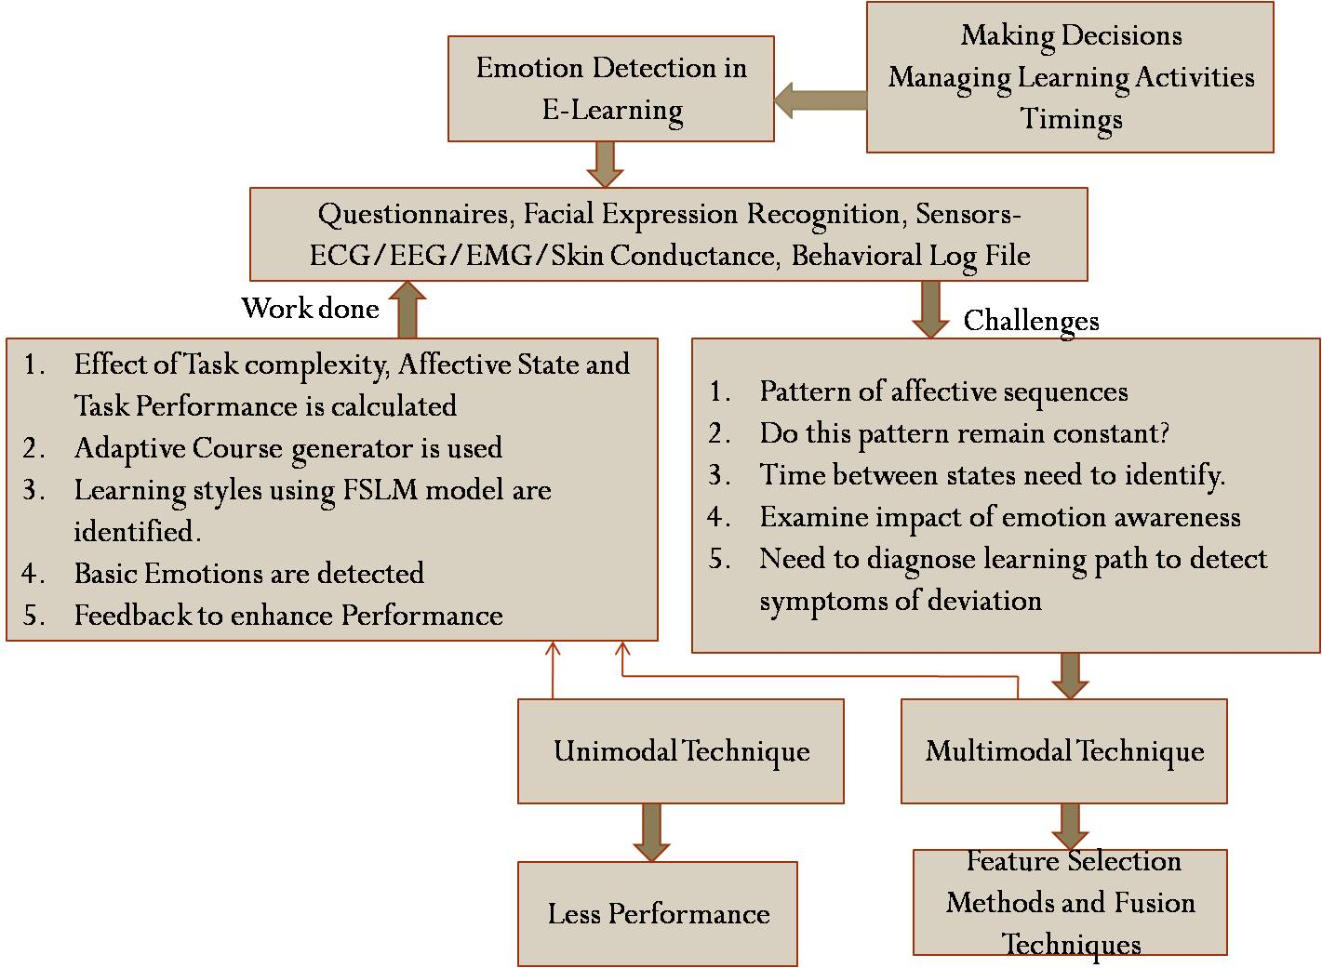
Fig. 5 Literature Analysis
As shown in Fig. 5, emotions have an enormous role in E-learning. Work previously done in the field of affective computing by various authors is as follows.
• Effect of Task complexity on affective state and task execution is identified by giving the mechanical job of cutting piece in rectangular and spherical structure to students.
• According to the learning styles and emotions of learner, course contents will be given to them to upgrade their performance.
• Learning styles of learners were recognized.
• Fundamental emotions were recognized by individual researchers.
• By analyzing the performance based on historical data, feedback is given to learners. Improvement in performance is observed using this method.

From the literature survey it is discovered that various modalities like facial expression recognition, questionnaires, interaction behaviour log, eye tracking, gestures/body motions, language and vocalization, text and sensors (Galvanic Skin Response (GSR), Electrocardiogram (ECG) and Electroencephalography (EEG) etc.) are used by researchers to recognize the emotions.
There are two different techniques unimodal and multimodal technique used by researchers to detect emotions in E-learning. There are different feature selection methods and fusion techniques used in multimodal technique. Different fusion techniques are early fusion (fusion at feature level), late fusion (fusion at output level) and hybrid fusion (mixture of early and late fusion). Performance of multimodal techniques is better than unimodal technique.
From this survey, it has been observed that most of the researchers have used facial expressions to recognize the emotion which is followed by sensors modality as shown in Fig. 6.

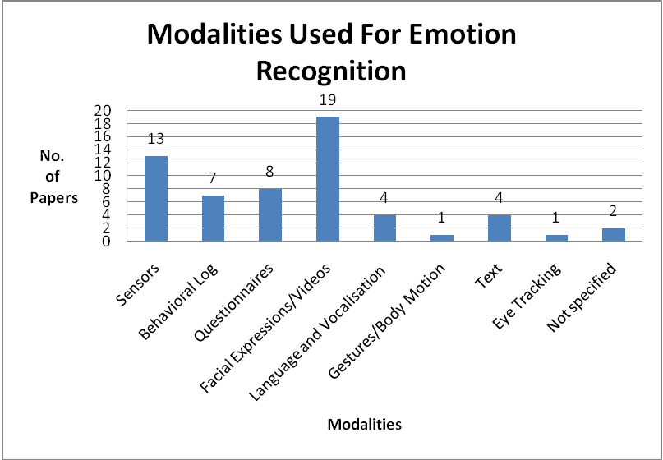

Fig. 6 Modalities Used for Emotion Recognition

From the literature survey done it was revealed that, researchers have predicted different emotions, developed the tools and the criticism is given to the learner. Due to criticism the improvements are observed in the learner’s performance. Most of the researchers have worked on academic emotions like Interest, engagement, confusion, frustration, boredom and hopefulness. Affect is generalized term used by the researchers, found in most of the papers.
Fig. 7 shows instruments/modalities used and parameters identified by researchers in the field of affective computing. After identifying parameters researchers has taken various actions like use of adaptive course generator, dynamic personalization, giving feedback based on state.
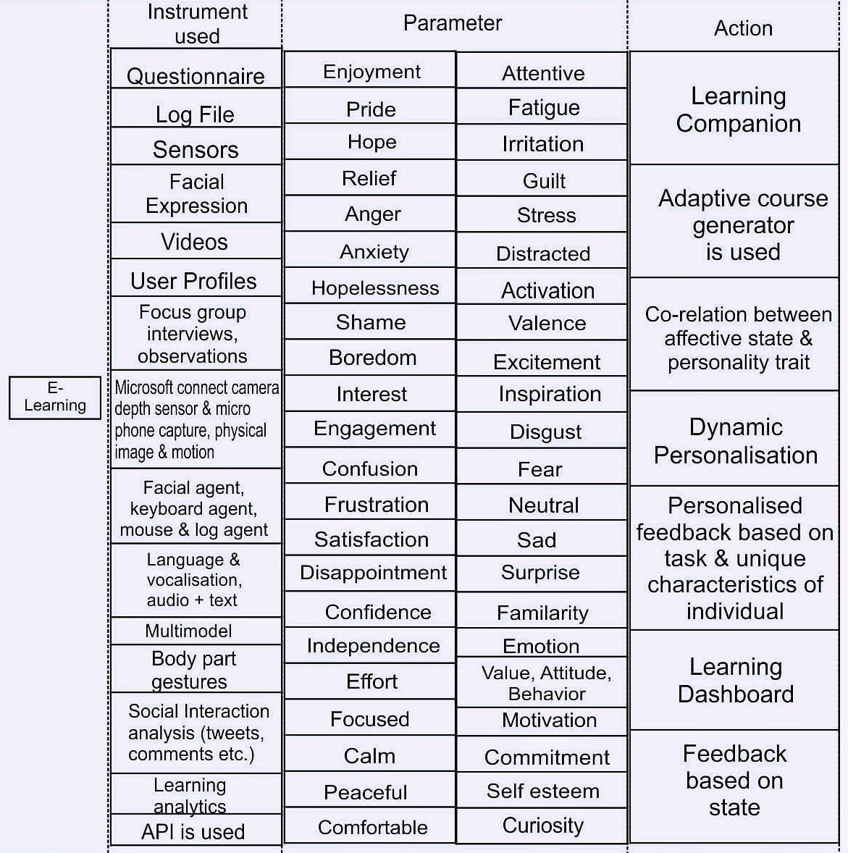
Fig.7 Instruments Used, Parameters Measured and Action taken by Researchers in Affective Computing Area
There are various challenges need to address in this field.
1. Instead of only finding affective state, there is a need to identify “What are the patterns of affective sequences of E-learner during E-learning?”
2. “Do these patterns remain constant throughout the course?”
3. Time span between two different emotions need to identify.
4. Need to examine result of emotion awareness.
5. Need to diagnose learning path to detect symptoms of deviation.
6. Data for few modalities is a major concern.

As given in Table 3, there are few affective datasets which are available for affect recognition. But for certain modalities like interaction log, data is a major concern.

Table 3 Affective Databases

Sr. No. | Dataset | Modalities | Affect | Purpose
1 | DEAP | Physiological | Yes | Implicit affective tagging from physiological signals
2 | ASCERTAIN | Face, physiological | Yes | Affect and personality recognition
3 | AMIGOS | Audio, visual, physiological, depth | Yes | Personality, mood and affect recognition
4 | DAiSEE | Video | Yes | Data set for affective states in E-Environments
5 | DECAF | Face, physiological | Yes | Affect recognition
6 | MANHOB-HCI | Face, audio, physiological, eye gaze | Yes | Emotion recognition
  - Conclusion
At present, emotion recognition can be carried out by using various modalities. Among them, facial expression and sensors are more widely used for emotion recognition, but emotion recognition based on gestures/body motions and eye tracking are less applied. This study has looked into the latest trends in Affective Computing in teaching and learning. In this chapter authors have discussed about what is the work already done in this area and what challenges need to be addressed. Specifically, we featured major studies in affective state recognition, which we believe vital segments of any affect detector system. Our study has affirmed other researcher’s discoveries that multimodal classifiers can broadly get utilized and beats unimodal classifiers. As acknowledged in this review, a portion of the key exceptional difficulties in this energizing field include: 1) Data collection 2) Finding patterns of affective sequences. 3) Do this pattern remain constant throughout learning? 4) Does the learning style influence the exhibition of student? and so on. These difficulties propose we are still a long way from creating a constant affective state detector which can successfully and emotionally speak with people and feel our emotions. Data for certain modalities is a major concern in the field of affective computing.

Acknowledgment
We are thankful to the Vishwakarma Institute of Information Technology, Pune for their encouragement towards completion of this survey.

References
[1] Goleman, D. (1995): Emotional intelligence. Bantam Books, New York.
[2] Kort, B., Reilly, R. (2001): Analytical Models of Emotions, Learning and Relationships: Towardsan Affect-sensitive Cognitive Machine. MIT Media Lab Tech Report No 548.
[3] Nell Buissink-Smith, Samuel Mann and Kerry Shephard, How Do We Measure Affective Learning in Higher Education? Journal of Education for Sustainable Development 2011 5: 101 DOI: 10.1177/097340821000500113.
[4] Picard, R. (2000) “Affective Computing”. The MIT Press, ISBN: 0262661152.
[5] L. Shulman, "Making Differences: A Table of Learning" Change, vol. 34, no. 6, p. 36–44, 2002.
[6] R. J. Marzano, "The Need for a Revision of Bloom's Taxonomy", In The New Taxonomy of Educational Objectives, p. 1-20, 2006.
[7] L.W. Anderson, and D.R. Krathwohl, et al (Eds..), "A Taxonomy for Learning, Teaching, and Assessing: A Revision of Bloom’s Taxonomy of Educational Objectives". Allyn & Bacon Boston, MA, 2001 .
[8] D'Mello, S. K., Craig, S.D., Witherspoon, A., McDaniel, B., and Graesser, A., (2008). Automatic Detection of Learner’s Affect from Conversational Cues. Journal of User Modeling and User-Adapted Interaction, 18(1-2), 45-80.
[9] Cocea, M., Weibelzahl, S. (2007). Eliciting motivation knowledge from log files towards Motivation diagnosis for Adaptive Systems. User Modeling 2007 LNCS Springer Berlin / Heidelberg.
[10] Weimin, X., Wenhong, X.(2007). E-Learning Assistant System Based on Virtual Human Interaction Technology, ICCS 2007, LNCS, Springer Berlin / Heidelberg.
[11] Graf, S., Kinshuk. (2006): An Approach for Detecting Learning Styles in Learning Management Systems, in Sixth IEEE International Conference on Advanced Learning Technologies, Kerkrade,Netherlands, pp. 161-163.
[12] Felder, R.M. and Silverman, L.K., (1988): Learning and teaching styles in engineering Education, Engineering Education, Vol. 78, No. 7, pp. 674–681.
[13] Merging Technology and Emotions: Introduction to Affective Computing.Brigham TJ. Med Ref Serv Q. 2017 Oct-Dec;36(4):399-407. doi: 10.1080/02763869.2017.1369289.
[14] Wu, Chih-Hung & Huang, Yueh-Min & Hwang, Jan-Pan. (2015). Review of affective computing in education/learning: Trends and challenges. British Journal of Educational Technology. 10.1111/bjet.12324.
[15] Jason Matthew Harley, Chapter 5 - Measuring Emotions: A Survey of Cutting Edge Methodologies Used in Computer-Based Learning Environment Research, Editor(s): Sharon Y. Tettegah, Martin Gartmeier, In Emotions and Technology, Emotions, Technology, Design, and Learning, Academic Press, 2016, Pages 89-114, ISBN 9780128018569.
[16] R. W. Picard, Affective Computing, M.I.T Media Laboratory Perceptual Computing Section Technical Report No. 321, 1995.
[17] T. C. Sandanayake and A. P. Madurapperuma, "Affective e-learning model for recognising learner emotions in online learning environment," 2013 International Conference on Advances in ICT for Emerging Regions (ICTer), Colombo, 2013, pp. 266-271.
[18] Kort, B., Reilly, R., and Picard, R. An affective model of the interplay between emotions and learning, In IEEE International Conference on Advanced Learning Technologies, no. 43-46 (2001).
[19] Khan, F.A., Weippl, E.R. & Tjoa, A.M. (2009). Integrated Approach for the Detection of Learning Styles and Affective States. In G. Siemens & C. Fulford (Eds.), Proceedings of ED-MEDIA 2009--World Conference on Educational Multimedia, Hypermedia & Telecommunications (pp. 753-761). Honolulu, HI, USA: Association for the Advancement of Computing in Education (AACE).
[20] Soujanya Poria,Erik Cambria,Rajiv Bajpai,Amir Hussain, A review of affective computing: From unimodal analysis to multimodal fusion, Information Fusion, Elsevier, Volume 37, September 2017, Pages 98-125.
[21] DAISEE: Dataset for Affective States in E-Learning Environments Gupta, A and Jaiswal, R and Adhikari, S and Balasubramanian, Vineeth N (2016) DAISEE: Dataset for Affective States in E-Learning Environments. arXiv. pp. 1-22.
[22] R. Subramanian, J. Wache, M. K. Abadi, R. L. Vieriu, S. Winkler and N. Sebe, "ASCERTAIN: Emotion and Personality Recognition Using Commercial Sensors," in IEEE Transactions on Affective Computing, vol. 9, no. 2, pp. 147-160, 1 April-June 2018.
[23] Calvo, Rafael & K. D'Mello, Sidney. (2010). Affect Detection: An Interdisciplinary Review of Models, Methods and their Applications, T. Affective Computing. 1. 18-37. 10.1109/T-AFFC.2010.1.
[24] Shen, L., Wang, M., & Shen, R. (2009). Affective e-Learning: Using “Emotional” Data to Improve Learning in Pervasive Learning Environment. Educational Technology & Society, 12 (2), 176–189.
[25] Ray, A., & Chakrabarti, A. (2016). Design and Implementation of Technology Enabled Affective Learning Using Fusion of Bio-physical and Facial Expression. Educational Technology & Society, 19(4), 112–125.
[26] Heart Rate Variability Signal Features for Emotion Recognition by using Principal Component Analysis and Support Vectors Machine, Han-Wen Guo and Yu-Shun Huang, Chien-Hung Lin, Jen-Chien Chien, and Koichi (2016).
[27] Coverage of Emotion Recognition for Common Wearable Biosensors,Terence K.L. Hui and R. Simon Sherratt(2018).
[28] Emotion and Personality Recognition Using Commercial Sensors, Ramanathan Subramanian ; Julia Wache; Mojtaba Khomami Abadi; Radu L. Vieriu(2016).
[29] Comparison between Euclidean and Manhattan distance measure for facial expressions classification, Latifa Greche; Maha Jazouli; NajiaEs-Sbai; Aicha Majda; Arsalane Zarghili(2017).
[30] Ashwin, T.S. and Guddeti, R.M.R., 2020. Impact of inquiry interventions on students in e-learning and classroom environments using affective computing framework. User Modeling and User-Adapted Interaction, pp.1-43.
[31] Wampfler, R., Klingler, S., Solenthaler, B., Schinazi, V.R. and Gross, M.,“Affective State Prediction Based on Semi-Supervised Learning from Smartphone Touch Data,” In Proceedings of the CHI Conference on Human Factors in Computing Systems, pp. 1-13, 2020.
[32]Shen, Liping & Wang, Minjuan & Shen, Ruimin. (2009). Affective e-Learning: Using "Emotional" Data to Improve Learning in Pervasive Learning Environment. Educational Technology & Society. 12. 176-189.
[33]Khan, Farman & Graf, Sabine & Weippl, Edgar & Tjoa, A Min. (2009). Integrated Approach for the Detection of Learning Styles & Affective States.
[34]Khan, Farman & Graf, Sabine & Weippl, Edgar & Tjoa, A Min. (2010). Identifying and Incorporating Affective States and Learning Styles in Web-based Learning Management Systems. Interaction Design and Architecture(s).
[35]Feidakis, Michalis & Daradoumis, Thanasis & Caballé, Santi & Conesa, Jordi. (2014). Embedding emotion awareness into e-learning environments. International Journal of Emerging Technologies in Learning (iJET). 9. 39. 10.3991/ijet.v9i7.3727.
[36]Carlos, Rachel & Reis, Rachel & Lyra, Kamila & Bittencourt, Ig & Rodriguez, Carla & Jaques, Patricia & Isotani, Seiji. (2015). Affective States in CSCL Environments A Systematic Mapping of the Literature. 10.1109/ICALT.2015.95.
[37]Rodrigues, Manuel & Fdez-Riverola, Florentino & Novais, Paulo. (2011). Moodle and affective computing: Knowing who's on the other side. Proceedings of the European Conference on Games-based Learning. 2. 678-685.
[38]Harley, Jason. (2015). Measuring Emotions: A Survey of Cutting-Edge Methodologies Used in Computer-Based Learning Environment Research.
[39]Frydenlund, Arvid & Rudzicz, Frank. (2015). Emotional Affect Estimation Using Video and EEG Data in Deep Neural Networks. Lect. Notes Comput. Sci.. 9091. 273-280. 10.1007/978-3-319-18356-5_24.
[40]J. Kumar and J. A. Kumar, “Machine learning approach to classify emotions using GSR,” Advanced Research in Electrical and Electronic Engineering, vol. 2, no. 12, pp. 72–76, 2015.
[41]T. S. Ashwin, J. Jose, G. Raghu and G. R. M. Reddy, "An E-Learning System with Multifacial Emotion Recognition Using Supervised Machine Learning," 2015 IEEE Seventh International Conference on Technology for Education (T4E), 2015, pp. 23-26, doi: 10.1109/T4E.2015.21.
[42]Bosch, Nigel & D'Mello, Sidney & Baker, Ryan & Ocumpaugh, Jaclyn & Shute, Valerie & Ventura, Matthew & Wang, Lubin & Zhao, Weinan. (2015). Automatic Detection of Learning-Centered Affective States in the Wild. International Conference on Intelligent User Interfaces, Proceedings IUI. 2015. 379-388. 10.1145/2678025.2701397.
[43]Behoora, Ishan & Tucker, Conrad. (2015). Machine learning classification of design team members' body language patterns for real time emotional state detection. Design Studies. 39. 10.1016/j.destud.2015.04.003.
[44]Hu, Qianyu & Bezawada, Shruthi & Gray, Allison & Tucker, Conrad & Brick, Timothy. (2016). Exploring the Link Between Task Complexity and Students’ Affective States During Engineering Laboratory Activities. V003T04A019. 10.1115/DETC2016-59757.
[45]Thompson, N. & McGill, Tanya. (2016). Genetics with Jean: the design, development and evaluation of an affective tutoring system. Educational Technology Research and Development. 10.1007/s11423-016-9470-5.
[46]Bahreini, Kiavash & Nadolski, Rob & Westera, Wim. (2015). Towards Real-time Speech Emotion Recognition for Affective E-learning. Education and Information Technologies. 1-20. 10.1007/s10639-015-9388-2.
[47]Ray, Arindam & Chakrabarti, Amlan. (2016). Design and Implementation of Technology Enabled Affective Learning Using Fusion of Bio-physical and Facial Expression. Educational Technology & Society. 19.
[48]A. K. Oryina and A. O. Adedolapo, "Emotion Recognition for User Centred E-Learning," 2016 IEEE 40th Annual Computer Software and Applications Conference (COMPSAC), 2016, pp. 509-514, doi: 10.1109/COMPSAC.2016.106.
[49]Laksitowening, Kusuma & Santoso, Harry & Hasibuan, Zainal. (2017). E-Learning Personalization Using Triple-Factor Approach in Standard-Based Education. Journal of Physics: Conference Series. 801. 012027. 10.1088/1742-6596/801/1/012027.
[50]López, Christian E. and Conrad S. Tucker. “From Mining Affective States to Mining Facial Keypoint Data: The Quest Towards Personalized Feedback.” (2017).
[51]Nathan, Shelena & Berahim, Mazniha & Ramle, Rosni. (2017). Rubric for Measuring Psychomotor and Affective Learning Domain. Pertanika Journal of Social Science and Humanities. 25. 101-108.
[52]Jan K. Argasiński, Paweł Węgrzyn, Affective patterns in serious games, Future Generation Computer Systems, Volume 92, 2019, Pages 526-538, ISSN 0167-739X, https://doi.org/10.1016/j.future.2018.06.013.
[53]Wu, Chih-Hung & Kuo, Bor-Chen. (2018). An Exploratory Study of Multimodal Perception for Affective Computing System Design. 10.1007/978-981-10-7398-4_20.
[54]Thesis: Visual Analytics of Cohorts in Educational Datasets https://www.it.iitb.ac.in/~sri/students/rwitajit-thesis.pdf
[55]D'Errico, Francesca & Paciello, Marinella & de Carolis, Berardina & Palestra, Giuseppe & Vattani, Alessandro. (2018). Cognitive Emotions in E-Learning Processes and their Potential Relationship with Students’ Academic Adjustment. International Journal of Emotional Education. 10. 89-111.
[56]S. Siddharth, T. Jung and T. J. Sejnowski, "Utilizing Deep Learning Towards Multi-modal Bio-sensing and Vision-based Affective Computing," in IEEE Transactions on Affective Computing, doi: 10.1109/TAFFC.2019.2916015.
[57]Yinghui Zhou and Xiaomei Tao. 2020. A Framework of Online Learning and Experiment System Based on Affective Computing. In Proceedings of the 2020 3rd International Conference on E-Business, Information Management and Computer Science. Association for Computing Machinery, New York, NY, USA, 619–624. DOI:https://doi.org/10.1145/3453187.3453405
[58]Troussas C., Virvou M. (2020) Affective Computing and Motivation in Educational Contexts: Data Pre-processing and Ensemble Learning. In: Advances in Social Networking-based Learning. Intelligent Systems Reference Library, vol 181. Springer, Cham. https://doi.org/10.1007/978-3-030-39130-0_5
[59]Ceccacci, Silvia et al. “Facial coding as a mean to enable continuous monitoring of student's behavior in e-Learning.” teleXbe (2021).
[60]Resham Arya, Jaiteg Singh, Ashok Kumar, A survey of multidisciplinary domains contributing to affective computing, Computer Science Review, Volume 40, 2021, 100399, ISSN 1574-0137, https://doi.org/10.1016/j.cosrev.2021.100399.
[61]Kumar, S. (2021), "Deep learning based affective computing", Journal of Enterprise Information Management, Vol. 34 No. 5, pp. 1551-1575. https://doi.org/10.1108/JEIM-12-2020-0536

